TUNED COLLECTOR OSCILLATOR



SIMULATION OUTPUT

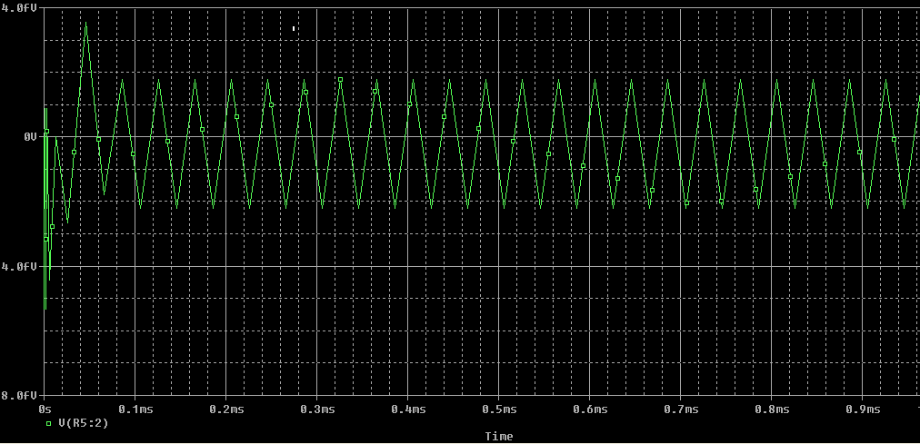

TWIN – T OSCILLATOR:



SIMULATION OUT PUT:

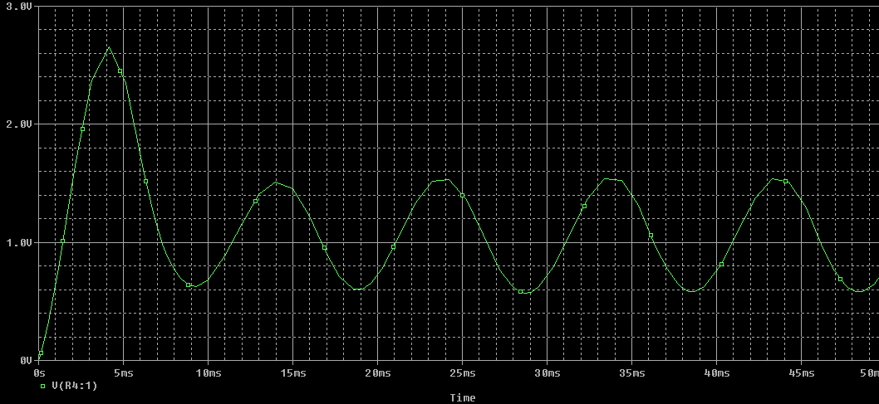

WEIN BRIDGE OSCILLATOR



SIMULATION OUTPUT:

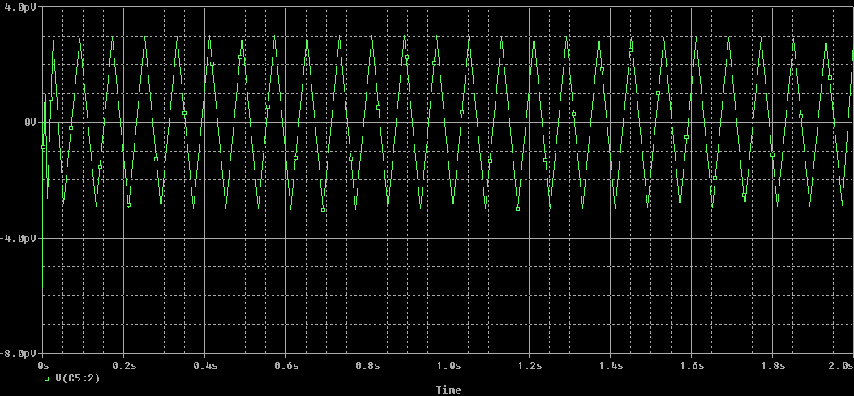

DOUBLE TUNED AMPLIFIER



SIMULATION OUTPUT:

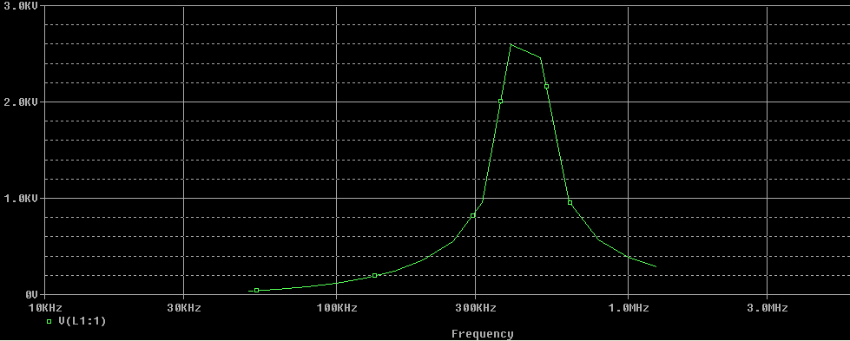

STAGGER TUNED AMPLIFIER



SIMULATION OUTPUT

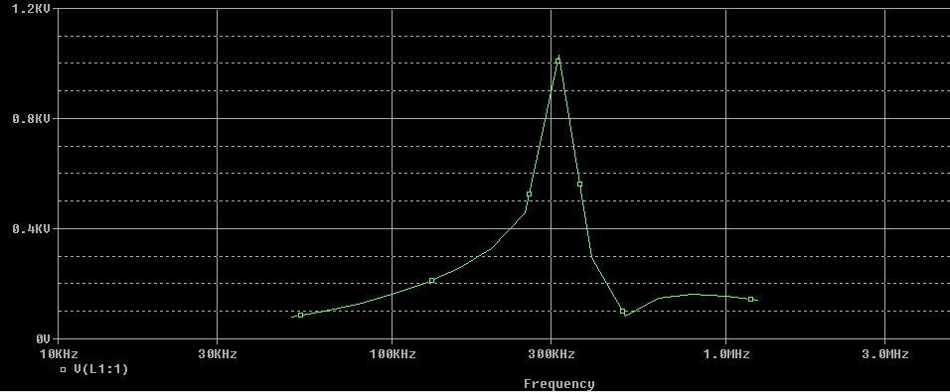

BISTABLE MULTIVIBRATOR:



SIMULATION OUTPUT

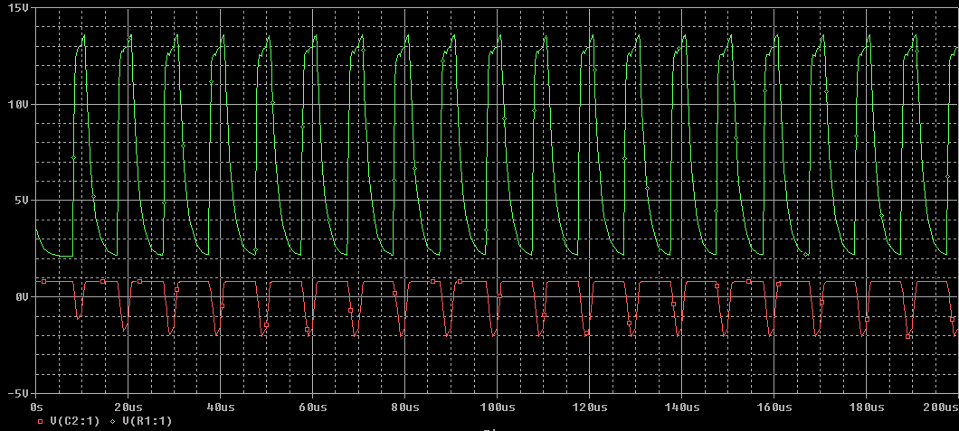

SCHMITT TRIGGER



SIMULATION OUTPUT:

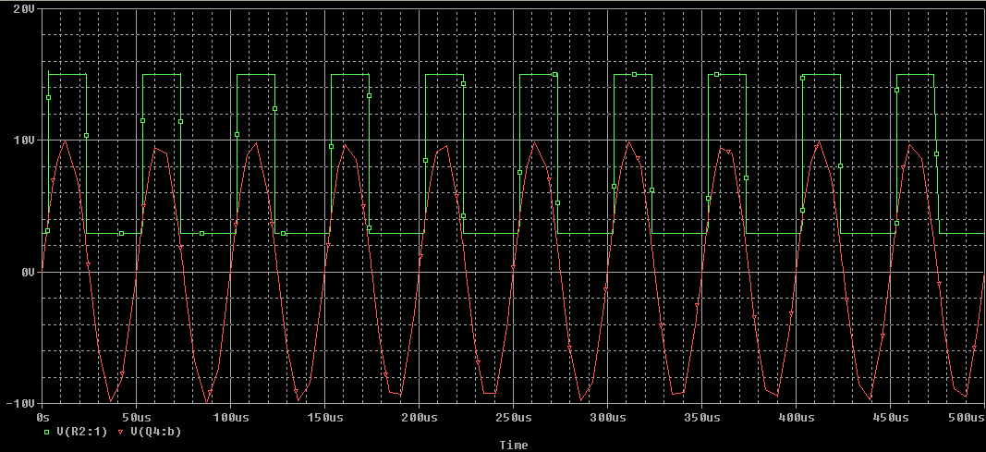

**ANALYSIS OF POWER AMPLIFIER**

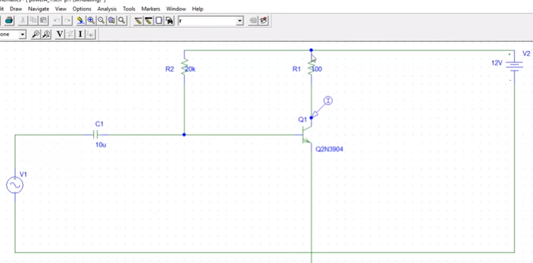

SIMULATION OUTPUT:



MONOSTABLE MULTIVIBRATOR



SIMULATION OUT PUT

